Experiment 7

Pranav - 2401010034
Aim : Rollback and Commit commands Create Teacher table with the following fields (Name, DeptNo, Date of joining, DeptName, Location, Salary)
  - Insert five records.
  - Give Increment of 25% salary for Mathematics Department.
  - Perform Rollback command.
  - Give increment of 15% salary for Commerce Department.
  - Perform Commit command.

Code:
CREATE TABLE Teacher (
Name VARCHAR(50),
DeptNo INT,
Date_of_Joining DATE,
DeptName VARCHAR(50),
Location VARCHAR(50),
Salary NUMBER(10,2)
);

a) Insert 5 records
INSERT INTO Teacher (TeacherName, DeptNo, DateOfJoining, DeptName, LocationName, SalaryAmt)
VALUES
('amit kumar', 10, '2021-01-10', 'mathematics', 'delhi', 40000),
('sunita devi', 20, '2020-03-15', 'commerce', 'mumbai', 35000),
('rahul sharma', 10, '2022-05-22', 'mathematics', 'delhi', 42000),
('priya nair', 30, '2019-11-01', 'science', 'kochi', 50000),
('aniket das', 20, '2023-02-14', 'commerce', 'kolkata', 32000);

b) Increase salary by 25% for Mathematics
UPDATE Teacher
SET Salary = Salary + (Salary * 0.25)
WHERE DeptName = 'Mathematics';
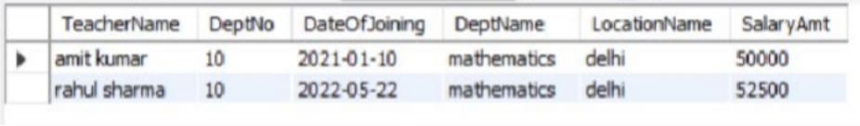

(c) Perform Rollback
ROLLBACK;
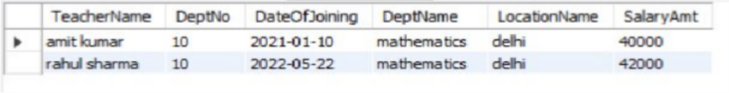

(d) Increase salary by 15% for Commerce
UPDATE Teacher
SET Salary = Salary + (Salary * 0.15)
WHERE DeptName = 'Commerce';

(e) Commit changes
COMMIT;
